**Installing FAST in Windows 7 Machines**

**Steps**

1. Open Control Panel and click "Programs" link

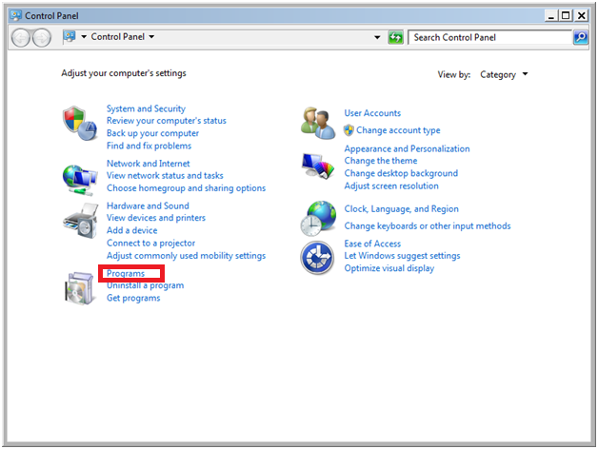

2. Under Programs and Feature click "Turn Windows features on or off" link

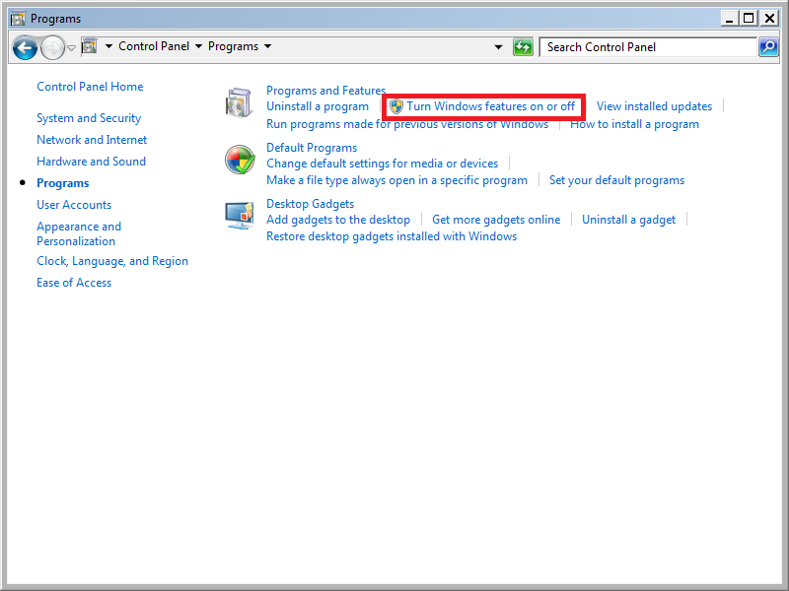

3. Verify "Web Management Tolls", "IIS6 Management Compatibility", "IIS Management Console", "IIS Management Scripts and Tools" and "IIS Management Service" check boxes are selected. If not selected then select it.

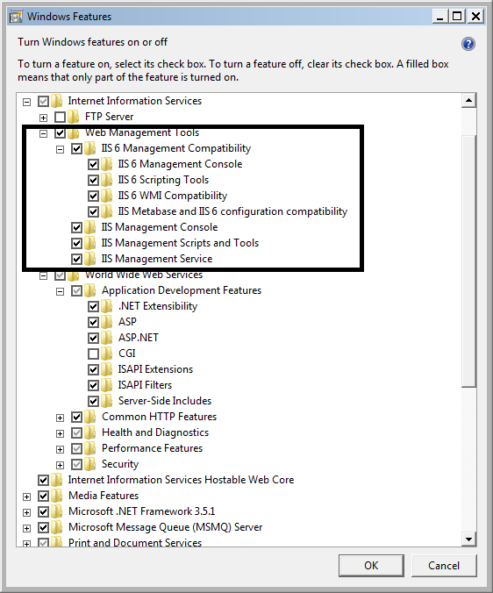

4. Verify "World Wide Web Services", "Application Development Features", ".NET Extensibility", "ASP", "ASP.Net", "ISAPI Extensions", "ISAPI Filters", "Service-Side Includes" check boxes are selected. If not selected then select it.

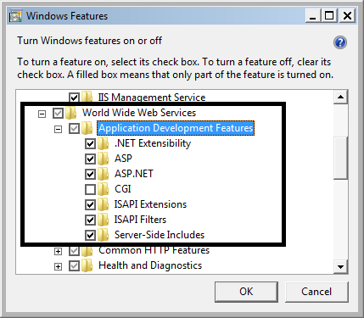

5. Go to the path C:\Windows\SysWOW64 through explorer.

Select cmd

right click and select "Run as administrator"

System will display the popup "Do you want to allow the following program to make changes to this computer"

Click OK

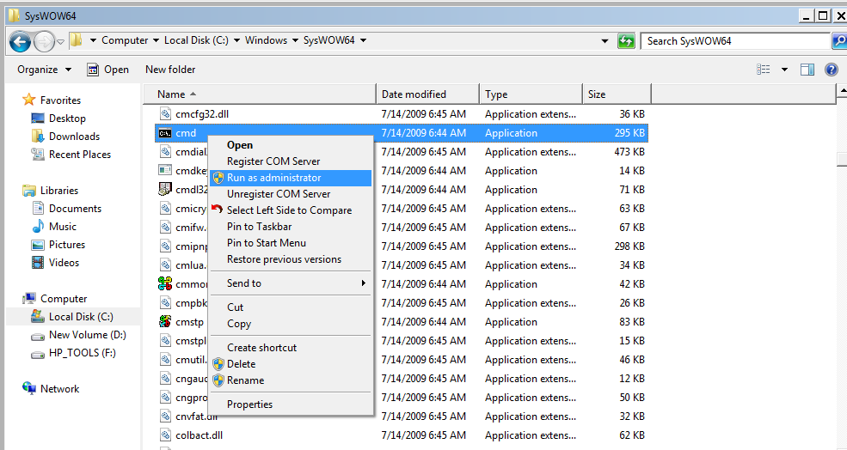

6. Copy the following and paste it into command prompt and press enter

cscript %SYSTEMDRIVE%\inetpub\adminscripts\adsutil.vbs SET W3SVC/AppPools/Enable32bitAppOnWin64 1

7. Copy the following and paste it into command prompt and press enter

If the FAST application is 3.5 Framework then

%SYSTEMROOT%\Microsoft.NET\Framework64\v2.0.50727\aspnet_regiis.exe -i

If FAST application is 4.0 framework then

%SYSTEMROOT%\Microsoft.NET\Framework64\v4.0.30319\aspnet_regiis.exe -i

8. Modify the following query according to your MSI path and paste it into command prompt and press enter

msiexec /i "C:\Users\rdonthireddy\Desktop\8.00.0017_New\ FAST Transaction System.msi" /qr /LVIERA "<Log location path>\FASTMSI.LOG"

9. After installing FAST. Open Internet Information Services (inetmgr)

Select SMSFast Application

Click Handler Message

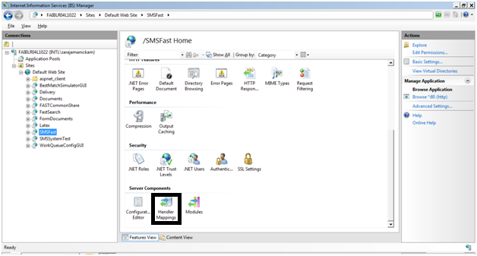

10.Right click and select "Add Wildcard Script Map"

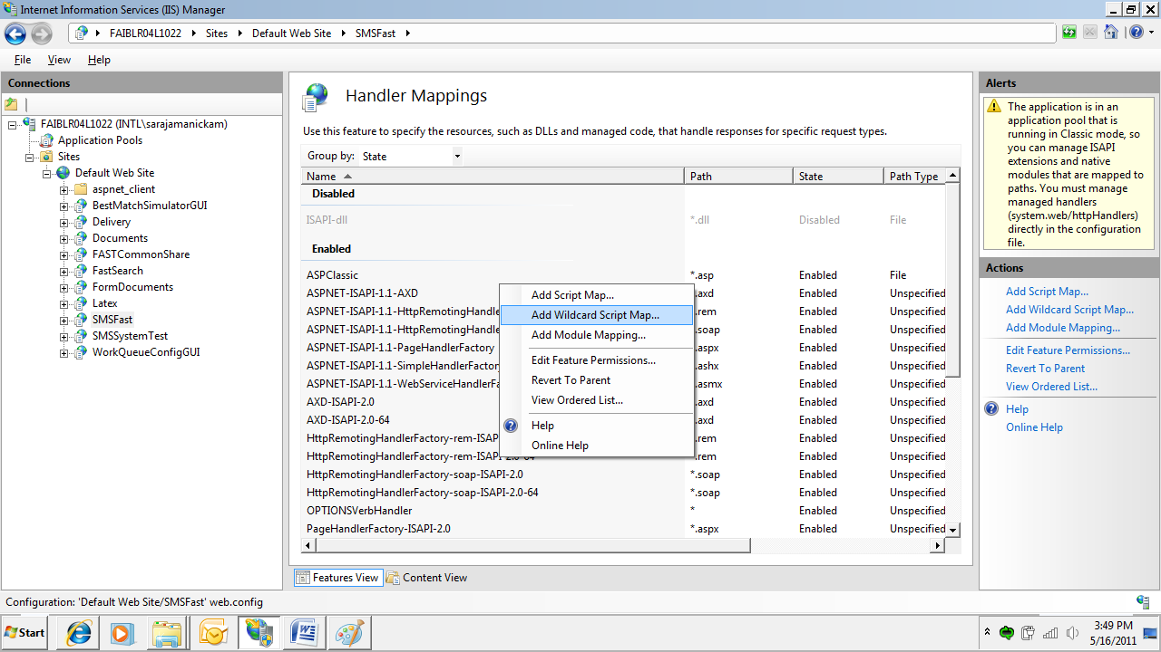

10. select aspnet_isapi.dll as Executable and provide the script map name and click OK.

If the FAST application is 3.5 framework then set Executable as

C:\Windows\Microsoft.NET\Framework\v2.0.50727\aspnet_isapi.dll

If the FAST application is 4.0 frame work then set Executable as

C:\Windows\Microsoft.NET\Framework\v4.0.30319\aspnet_isapi.dll

**Wildcard Script Map for SMSFast**

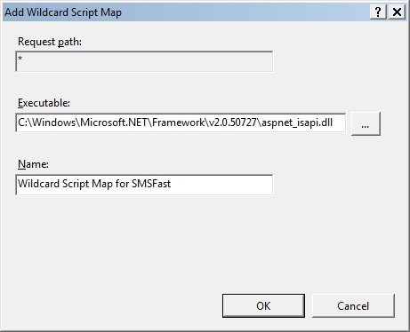

11. Modify FastAuthGUI Web.config file FAFServiceConfigFile key value as

C:\Program Files (x86)\SMS\FastAuthGUI\ServiceConfig.xml

12. Modify FAFGUIHelper Web.config file FAFServiceConfigFile key value as

C:\Progra~2\SMS\FAFGUIHelper\ServiceConfig.xml

13. Load Internet Information Services

Select SMSFast

Right click and Select "Add Application"

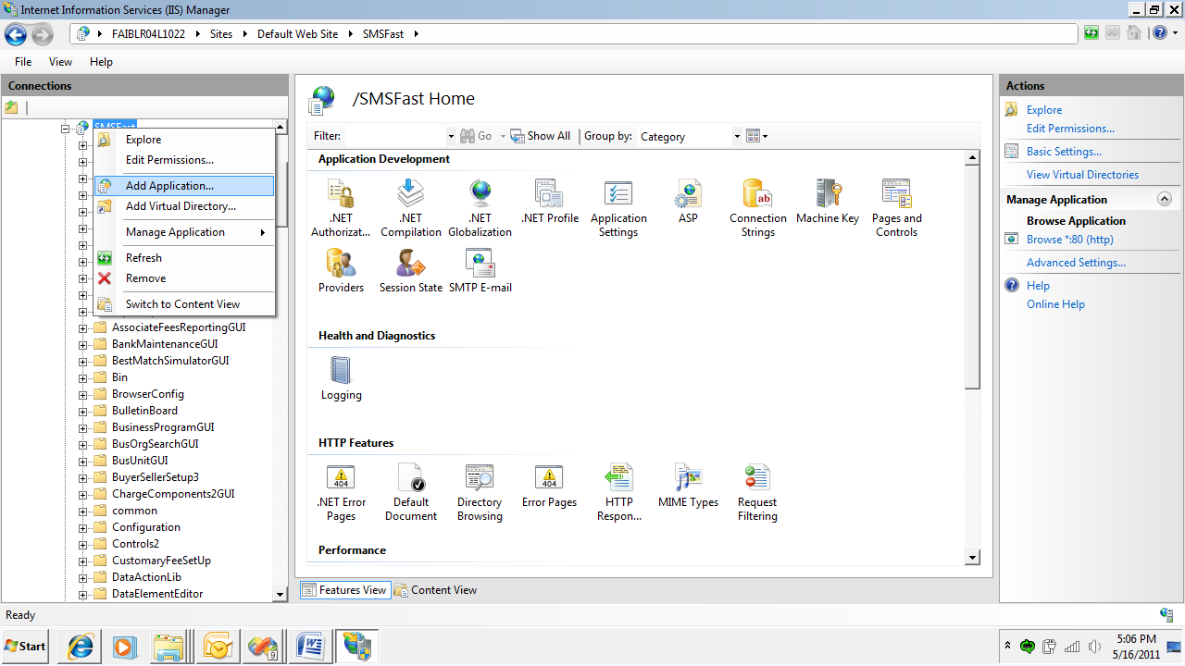

14. Enter Alias as FastNetApp1

Physical Path as C:\Program Files (x86)\SMS

Click Select button to select proper Application pool

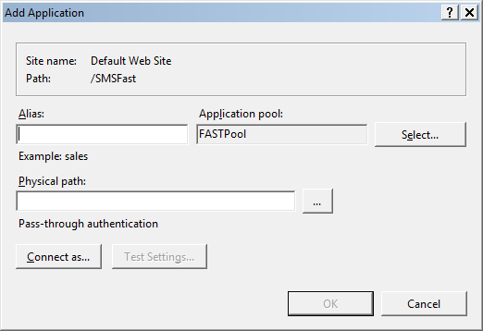

15. Select DotNetPool#1 and click OK

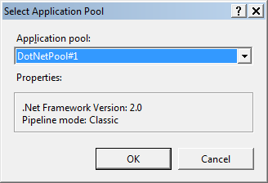

Repeat Step 14 and 15 and create the below applications if FAST application is .Net 3.5 Framework

|  |  |  |
| --- | --- | --- |
| **Application Alias** | **Pool Name** | **Physical Path** |
| FastNetApp2 | DotNetPool#2 | C:\Program Files (x86)\SMS |
| FastNetApp3 | SplitDocPool | C:\Program Files (x86)\SMS |
| FastNetApp4 | DotNetPool#4 | C:\Program Files (x86)\SMS |
| FastSystemStatus | SystemStatusPool | C:\Program Files (x86)\SMS\SystemStatusGUI |

If FAST application is 4.0 Framework then please do the following when application pool's are not creating by default after FAST application.

|  |  |  |
| --- | --- | --- |
| **Application Alias** | **Pool Name** | **Physical Path** |
| FastNetApp1 | ASP.NET v4.0 DotNetPool#1 | C:\Program Files (x86)\SMS |
| FastNetApp2 | ASP.NET v4.0 DotNetPool#2 | C:\Program Files (x86)\SMS |
| FastNetApp3 | ASP.NET v4.0 SplitDocPool | C:\Program Files (x86)\SMS |
| FastNetApp4 | ASP.NET v4.0 DotNetPool#4 | C:\Program Files (x86)\SMS |
| FastSystemStatus | ASP.NET v4.0 SystemStatusPool | C:\Program Files (x86)\SMS\SystemStatusGUI |

16. Open Machine.config from C:\Windows\Microsoft.NET\Framework\v2.0.50727\CONFIG

Modify C:\Program Files\SMS into C:\Program Files (x86)\SMS when FAST application is using 3.5 Framework. If FAST application is using 4.0 Framework then please Open Machine.config from C:\Windows\Microsoft.NET\Framework\v4.0.30319\CONFIG

Modify C:\Program Files\SMS into C:\Program Files (x86)\SMS

**Note** : We have to update all config files (web .config, machine.config) FAFServiceConfigFile key value path as C:\Program Files (x86)\SMS instead of C:\Program Files\SMS

17. Please verify whether Enterprise Insrumentation is installed in your machine by browsing the below path.

C:\Program Files (x86)\Microsoft Enterprise Instrumentation

If it is not installed then please install it using the below path

\\faiblr04wit02\Setup\Enterprise Instrumentation

For Enterprise Instrumentation .Net Framework 1.1 is required. So If your system does not contain .Net framework 1.1 then please deploy from \\faiblr04wit02\Setup\Enterprise Instrumentation

18. Please verify whether ingrian is installed in your machine in the below path C:\Program Files (x86)\SafeNet ProtectApp

If not installed then please install the below two MSI from FAF20\3rdPartyComponents\Ingrian\Ingrain 5.1.2 installation

611-009849-001_datasecure_protectapp_dotnet_32bit_windows_v5.1.2.000-005.exe

611-009850-008_SafeNetProtectAppICAPI_32b_windows_v5.1.2.000-004.exe

Note : please install through command prompt

Replace all entries from C:\Program Files\SMS to **C:\Program Files (x86)\SMS**

And from c:\progra~1\SMS to **c:\progra~2\SMS**